Flex PCB Tester - Build Notes

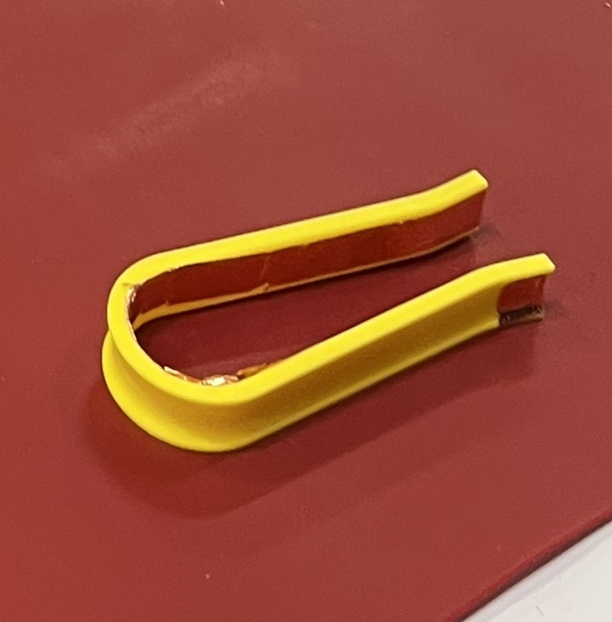

- Print
- Wrap it in copper tape from the contacts (where you pinch it together), and all the way around the inside of the horseshoe.
  - Optional: You can start / finish on the outside ends of the external channel (where you hold it) to help prevent the copper tape from peeling up during use.
- Make sure the copper tape is continuous / no breaks anywhere.
- To Test / Use:
  - Plug the Flex PCB into a Battery Tester
  - Pinch the center contact of the FlexPCB (the switch tester should light up)
    - You might need to fiddle with it a bit until you get the hang of it

